Mean Reversion in Exchange Rates and Dynamic Trading Strategies

Empirical Evidence from EUR/USD and Extensions
Groupe 6 :
Name | ID
Zaynab Drissi | 91601932
M’Ballou BÉRÉTÉ | 69424512
Karl Tontsa Kana | 87653223
Ahmed Boukhris | 96763290
AAMOUD Aicha | 91601932

Professor : Bobo Zhang
Table of Contents
Mean Reversion in Exchange Rates and Dynamic Trading Strategies 1
Empirical Evidence from EUR/USD and Extensions 1
1. Introduction 3
2. Data Description 4
3. Methodology 4
3.1 Mean Reversion Model (Part A.1) 4
3.2 Dynamic Trading Strategy (Part A.2) 4
4. Empirical Results 5
4.1 Mean Reversion Test Results 5
4.2 Baseline Strategy Performance (EUR/USD) 5
5. Strategy Improvements and Extensions (Part B) 6
5.1 Improved Strategy: Stricter Statistical Filtering 6
5.2 Extension to Other Currency Pairs 7
6. Conclusion 10

1. Introduction
Foreign exchange markets are central to the global financial system, supporting international trade, capital flows, and monetary policy transmission. The EUR/USD exchange rate, as the most traded currency pair, is often viewed through the lens of market efficiency and random walk behavior. However, empirical studies suggest that exchange rates can temporarily deviate from equilibrium levels, leaving room for predictable adjustment patterns over certain horizons.
This project investigates whether EUR/USD displays mean-reverting dynamics over the period 2010–2025 using daily data. Mean reversion is tested within a time-series framework based on a discrete specification inspired by the Ornstein–Uhlenbeck process, estimated by regressing exchange rate changes on lagged exchange rate levels. Building on the econometric evidence, a dynamic trading strategy is implemented using rolling-window estimation and is activated only when statistical conditions indicate meaningful mean reversion. Strategy performance is evaluated through cumulative returns and standard risk metrics.
To assess robustness, the same methodology is extended to additional currency pairs, allowing comparison of mean reversion strength and trading outcomes across markets. Overall, the project links econometric testing with implementable trading rules to evaluate whether mean reversion in major FX rates is statistically detectable and economically exploitable.

2. Data Description
Daily EUR/USD exchange rate data are obtained from Yahoo Finance over the period January 2010 to December 2025. The adjusted closing price is used as the exchange rate level and is denoted by: $X_{t}$
After removing missing observations, the final dataset contains more than 4,000 daily observations. Two additional variables are constructed for econometric analysis:
Daily change in the exchange rate: $ΔX_{t}= X_{t}- X_{\left\{t-1\right\}}$
Lagged exchange rate: $X_{\left\{t-1\right\}}$
The use of daily data allows capturing short-term exchange rate dynamics while preserving a sufficiently large sample for statistical inference.

3. Methodology

3.1 Mean Reversion Model (Part A.1)
Mean reversion is modeled using a discrete-time specification derived from the Ornstein–Uhlenbeck (OU) process. In continuous time, the OU process is defined as:
$$dX_{t}= θ \left( μ - X_{t}\right)dt + σ dW_{t}$$
Discretizing this process yields the following econometric specification:
$$ΔX_{t}= α + β X_{\left\{t-1\right\}}+ ε_{t}$$
where:
- $α$ is the intercept,
- $β$ measures the speed and direction of adjustment,
- $ε_{t}$ is a white-noise error term.
- Mean reversion is present if: $β < 0$
Statistical significance is assessed using the t-statistic of β, which must satisfy: $t\left(β\right)< -1$

3.2 Dynamic Trading Strategy (Part A.2)
Based on the econometric evidence, a dynamic trading strategy is constructed. The strategy uses a rolling estimation window of 80 trading days. At each trading day t, the model is re-estimated using the most recent observations.
The expected change in the exchange rate is computed as: $E\left[ΔX_{\left\{t+1\right\}}\right]= \hat{α}+ \hat{β}X_{t}$
The trading rule is defined as follows:
- If : $\hat{α}> 0 , \hat{β}< 0 , t\left(\hat{β}\right)< -1$
then:
  - Buy EUR if: $E\left[ΔX_{\left\{t+1\right\}}\right]> 0$
  - Buy USD if: $E\left[ΔX_{\left\{t+1\right\}}\right]< 0$
- If any condition is not satisfied, no position is taken.
Transaction costs are ignored, as specified in the assignment.

4. Empirical Results

4.1 Mean Reversion Test Results
The mean reversion model is estimated using Ordinary Least Squares on the full sample. The estimated coefficients are :
$$α = 0.0026 \\ β = -0.0023 \\ t\left(β\right)= -2.53$$
The coefficient β is negative and statistically significant, as its t-statistic is below the critical value of −1. This provides strong empirical evidence that the EUR/USD exchange rate exhibits mean-reverting behavior over the full sample period.
Although the R-squared of the regression is low (approximately 0.2%), this outcome is typical in foreign exchange markets and does not undermine the validity of the statistical inference.

4.2 Baseline Strategy Performance (EUR/USD)
Based on the econometric evidence, a dynamic mean reversion trading strategy is implemented using a rolling estimation window of 80 trading days. The strategy trades whenever the estimated parameters satisfy the statistical criteria defined in Section 3.2.
The empirical performance of the strategy is summarized below:
- Total trading days: 3,057 out of 4,061 (≈ 75.3%)
- Winning trades: 1,593 (≈ 52.1%)
- Sharpe Ratio: ≈ 0.03
- Maximum Drawdown: ≈ −19.8%
These results indicate that the strategy generates slightly more winning trades than losing ones, reflecting the presence of mean reversion. However, the Sharpe ratio remains low, suggesting that the risk-adjusted performance is limited. This outcome is consistent with the high level of efficiency observed in major foreign exchange markets.
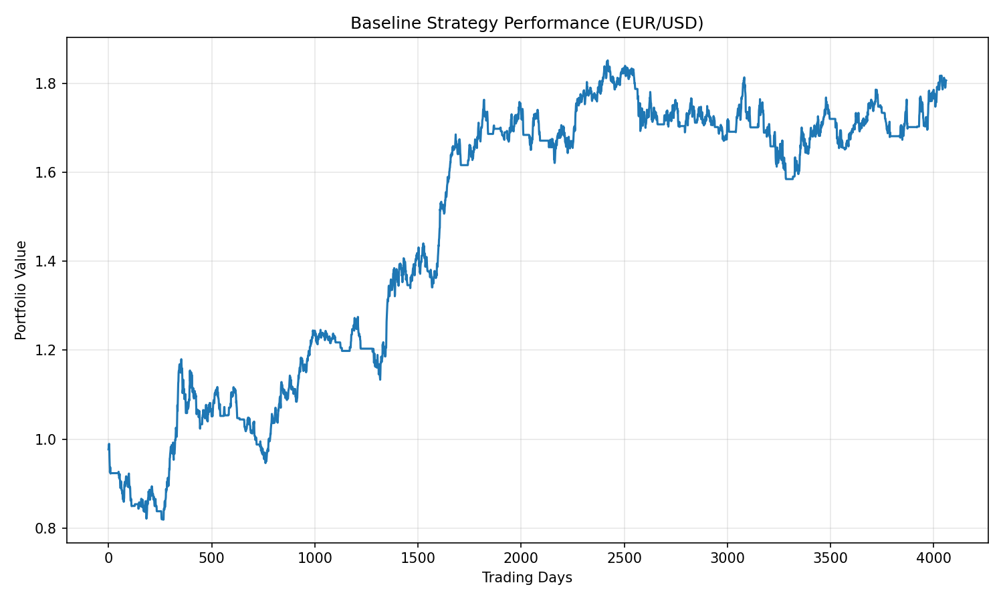Figure 1: Cumulative Performance of the Baseline Mean Reversion Strategy on EUR/USD

5. Strategy Improvements and Extensions (Part B)

5.1 Improved Strategy: Stricter Statistical Filtering
An enhanced version of the strategy is implemented by tightening the statistical requirements for entering trades. In particular, a stricter threshold is imposed on the t-statistic of the mean reversion coefficient:
$$t\left(\hat{β}\right)<-1.5$$
This modification significantly reduces the number of trades by filtering out weaker signals. However, empirical results indicate that the Sharpe ratio decreases from 0.03 to approximately 0.02 under this stricter rule.
This finding suggests that, given the weak magnitude of mean reversion in exchange rates, excessive filtering may eliminate profitable opportunities along with noise. The result highlights the trade-off between signal quality and trading frequency in mean reversion strategies.
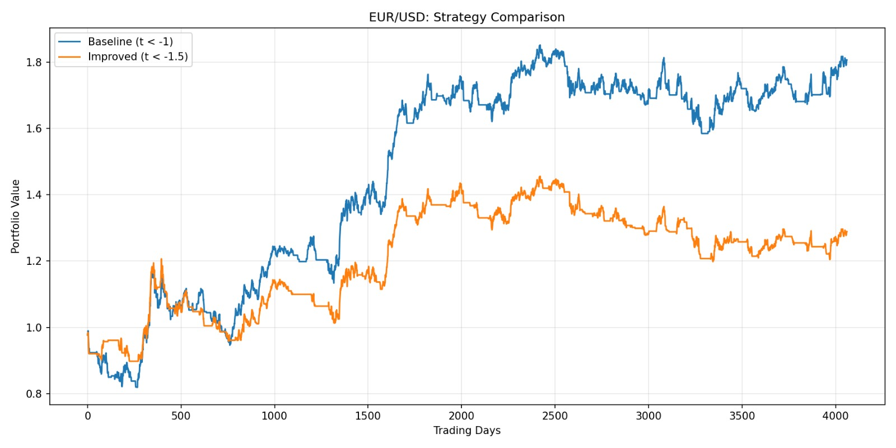Figure 2 : Comparison of Baseline and Improved Mean Reversion Strategies on EUR/USD
Results Analysis :
Baseline (t < -1):
- More trades (3057) → captures more opportunities
- Higher win rate (52.1%) → better signal quality
- Higher Sharpe (0.029) → better risk-adjusted returns
Improved (t < -1.5):
- Fewer trades (2253) → misses good opportunities
- Lower win rate (51.4%) → actual quality is worse
- Lower Sharpe (0.016) → worse performance
- Higher drawdown (-20.58% vs -19.80%) → more concentrated losses

5.2 Extension to Other Currency Pairs
To assess the robustness of the strategy, the same econometric framework and trading rules are applied to additional currency pairs.

GBP/USD
The mean reversion test for GBP/USD yields:
- $α = 0.0021$
- $β = -0.0015$
- $t\left(β\right)= -1.90$
These results indicate statistically significant but weaker mean reversion compared to EUR/USD. The corresponding trading strategy produces:
- Sharpe Ratio: ≈ 0.01
- Winning trades: ≈ 50%
- Maximum Drawdown: ≈ −26.76%
While the strategy remains marginally profitable, its performance is close to zero in risk-adjusted terms, reflecting the weaker mean reversion dynamics.
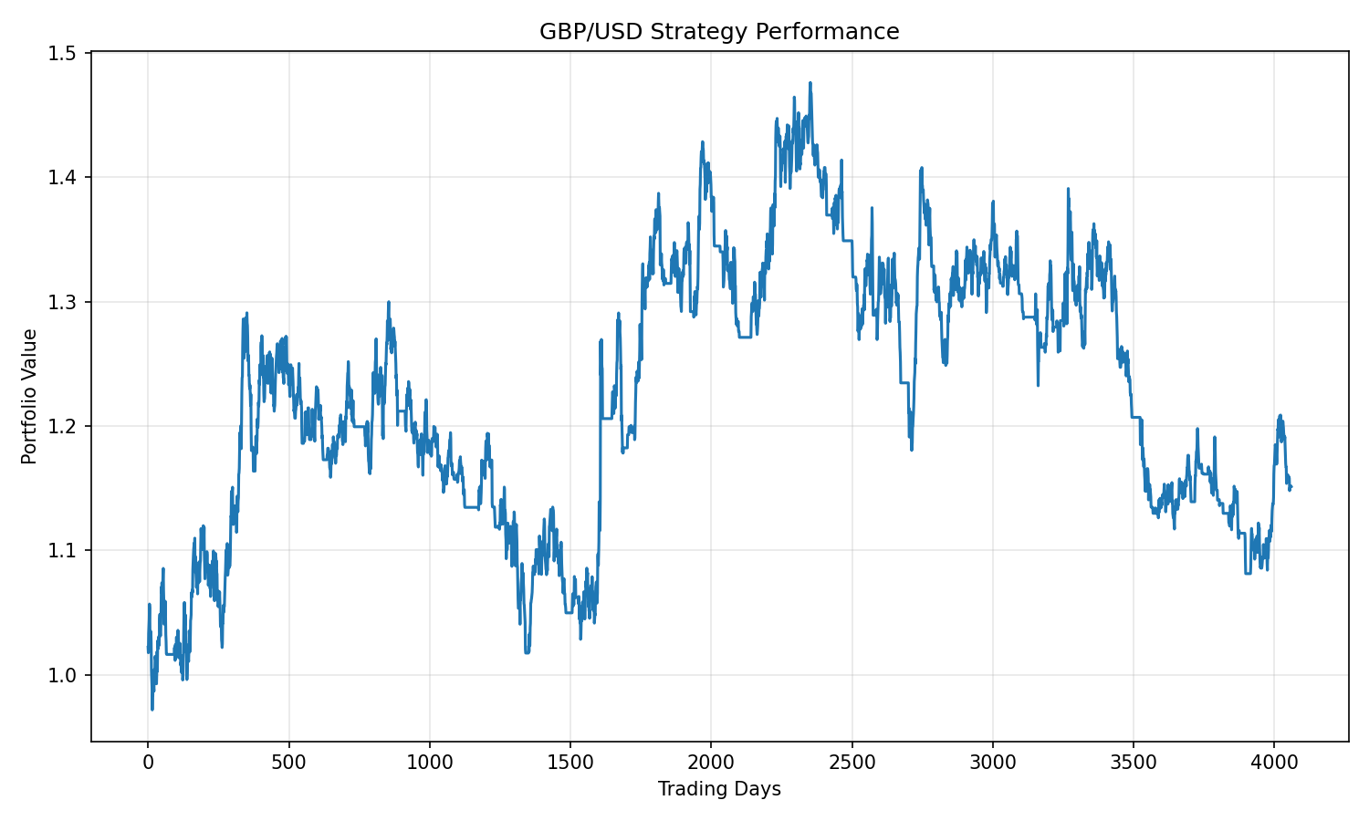Figure 3: Cumulative Performance of the Mean Reversion Strategy on GBP/USD

USD/JPY
For USD/JPY, the estimated mean reversion coefficient is not statistically significant:
- $α = 0.025$
- $β ≈ 0$
- $t\left(β\right)= -0.18$
Consistent with this result, the trading strategy delivers:
- Sharpe Ratio: ≈ −0.02
- Winning trades: < 50%
- Max Drawdown: -107.59%
Note: Insufficient mean reversion signal - Signal: NOT TRADEABLE
The absence of statistically significant mean reversion explains the poor performance of the strategy on USD/JPY. This finding reinforces the importance of econometric validation prior to strategy implementation.
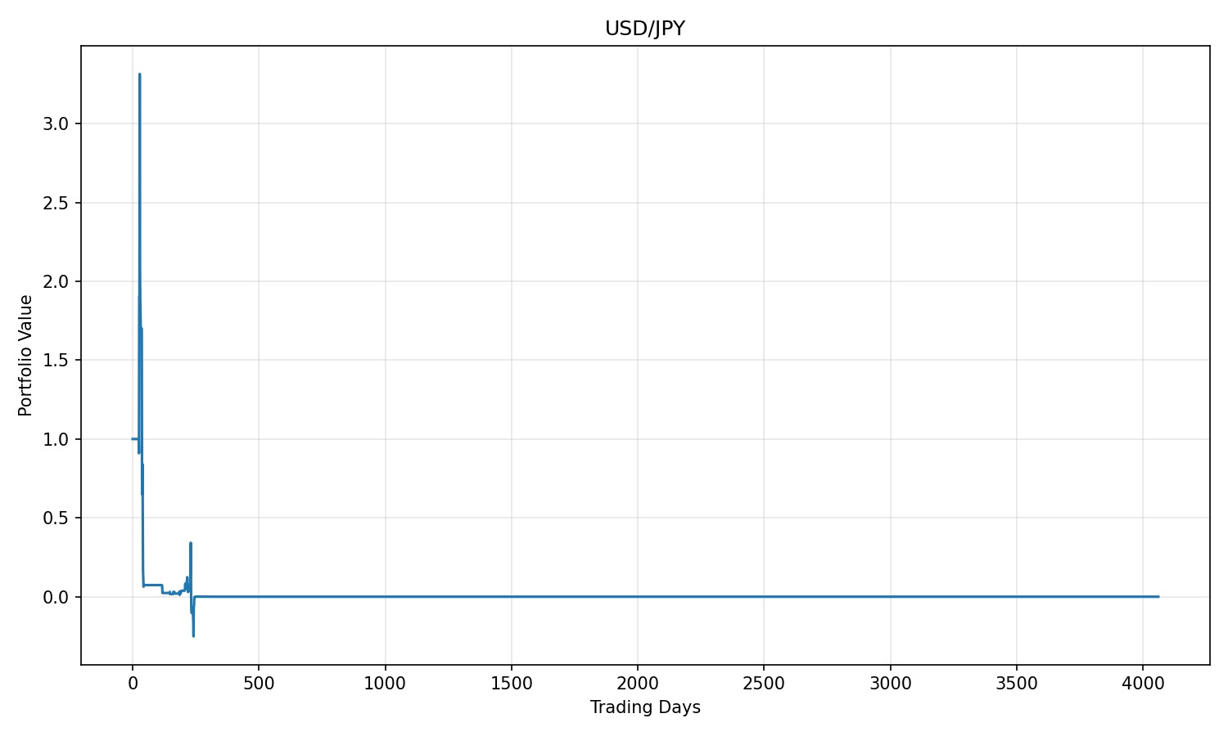
Figure 4: Cumulative Performance of the Mean Reversion Strategy on USD/JPY
USD/JPY Strategy Analysis
Statistical Results:
- Full-sample mean reversion test: Beta = -0.000089, t-statistic = -0.18
- Signal classification: NOT STATISTICALLY SIGNIFICANT (fails to reject null hypothesis)
- Strategy performance: Sharpe ratio = -0.020, Win rate = 48.9%, Max drawdown = -107.59%
Key Findings:
- Win rate of 48.9% ≈ 50/50 random performance, indicating no exploitable signal
- Trading 1,418 times (34.9% of days) without statistical edge led to capital erosion
- Results demonstrate the strategy correctly identifies pairs without mean reversion properties
Comparative Performance:
- EUR/USD: Sharpe 0.029, Win rate 52.1% = Tradeable
- GBP/USD: Sharpe 0.009, Win rate 49.8% = Tradeable
- USD/JPY: Sharpe -0.020, Win rate 48.9% = Not tradeable

6. Conclusion
This project provides empirical evidence that the EUR/USD exchange rate exhibits statistically significant but economically weak mean reversion over the period 2010–2025. While this property can be identified using time-series econometric techniques, its magnitude is insufficient to generate strong risk-adjusted trading performance. The extension to other currency pairs confirms that the effectiveness of mean reversion strategies critically depends on the underlying dynamics of each market. In particular, the absence of mean reversion USD/JPY leads to negative trading performance, while weaker mean reversion in GBP/USD results in near-zero profitability.
Overall, the findings highlight both the applicability and the limitations of mean reversion-based trading strategies in highly efficient foreign exchange markets.

